**Name: Aditya Rameshwar Bahe**

**Roll no: 16 Branch: D1**

Problem statement no.1:

You are tasked with designing a class called Calculator that will have the following two methods:

* addNumbers - This method will take two integer parameters a and b, and will return their sum as an integer.
* multiplyNumbers - This method will take three integer parameters a, b, and c, and will return their product as an integer.

You are also required to design a main method in the same/different class that will do the following:

* Ask the user to input two integer values for a and b.
* Call the addNumbers method with the two integer values obtained from the user, and store the result in a variable.
* Print the result to the console.
* Ask the user to input three integer values for a, b, and c.
* Call the multiplyNumbers method with the three integer values obtained from the user, and store the result in a variable.
* Print the result to the console.

**Java code:**

//Question 1

import java.util.Scanner;

class Opretions{

    int add(int x, int y){

        return x+y;

    }

    int mul(int x1,int y1,int z1){

        return x1*y1*z1;

    }

}

class Assignment1{

   static int a,b,c;

   static Scanner s= new Scanner(System.in);

    public static void main(String[] args) {

        System.out.println("Enter the values to be added");

        a=s.nextInt();

        b=s.nextInt();

        Opretions op=new Opretions();

        System.out.println("Sum="+op.add(a,b));

        System.out.println("Enter the values to be Multiplied");

        a=s.nextInt();

        b=s.nextInt();

        c=s.nextInt();

        System.out.println("Muliplication="+op.mul(a,b,c));

    }

}

**Screen shot of output:**

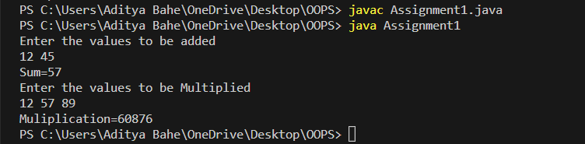

**Problem statement no.2:**

You are tasked with designing a class called Employee that will have the following instance variables:

* name - A string representing the name of the employee.
* age - An integer representing the age of the employee.
* salary - A double representing the salary of the employee.

You are also required to design a class method called calculateBonus that will take an Employee object as a parameter, and will return the bonus amount for that employee. The bonus amount will be calculated as follows:

* If the employee is less than 30 years old, the bonus amount will be 10% of their salary.
* If the employee is between 30 and 40 years old (inclusive), the bonus amount will be 15% of their salary.
* If the employee is over 40 years old, the bonus amount will be 20% of their salary.

You are also required to design a main method in a separate class that will do the following:

* Create an Employee object with the name, age, and salary provided by the user.
* Call the calculateBonus method with the Employee object created in step 1.
* Print the bonus amount to the console.

**Java code:**

//Question 2

import java.util.Scanner;

class Employee{

     int age;

     String name;

     double salary;

 double CalculateBonus(Employee e){

    double bonus;

    if(e.age < 30)

        bonus=0.1*e.salary;

    else if(e.age >30 && e.age <= 40)

        bonus=0.15*e.salary;

    else

        bonus=0.2*e.salary;

    return bonus;

  }

}

class Assignment1{

   static Scanner s= new Scanner(System.in);

   static Employee emp=new Employee();

    public static void main(String[] args) {

        System.out.println("Enter the name of the employee");

        emp.name=s.nextLine();

        System.out.println("Enter the age of the employee");

        emp.age=s.nextInt();

        System.out.println("Enter the salary of the employee");

        emp.salary=s.nextDouble();

        double b=emp.CalculateBonus(emp);

        System.out.println("Bonus of employee is "+b);

    }

}

**Screen shot of output:**

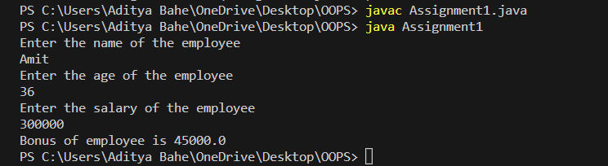

**Problem statement no.3:**

 Write a Java program that defines a Rectangle class with two instance variables - length and width.

* The class should have a constructor that takes two parameters and initializes the instance variables using this keyword.
* The class should also have three methods - getLength, getWidth, and getArea - that return the values of the instance variables and the area of the rectangle.
* In the main method, create two Rectangle objects using the constructor and print out their length, width, and area.

**Java code:**

//Question 3

class Rectangle{

     double length,width,area;

     Rectangle(double length, double width){

        this.length=length;

        this.width=width;

     }

    double getLength(){

        return length;

        }

    double getWidth(){

        return width;

    }

    double getArea(){

        return length*width;

    }

}

class Assignment1{

   public static void main(String[] args) {

    Rectangle rect1=new Rectangle(10,5);

   Rectangle rect2=new Rectangle(20,0.5);

   System.out.println("lenght of 1st rectangle="+rect1.getLength());

   System.out.println("lenght of 2nd rectangle="+rect2.getLength());

   System.out.println("Width of 1st rectangle="+rect1.getWidth());

   System.out.println("Width of 2nd rectangle="+rect2.getWidth());

   System.out.println("Area of 1st rectangle="+rect1.getArea());

   System.out.println("Area of 2nd rectangle="+rect2.getArea());

   }

}

**Screen shot of output:**

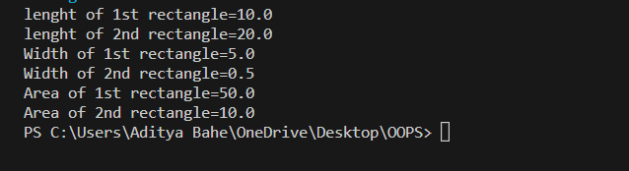

**Problem statement no.4:**

Create a class Rectangle with  
   data members length, breadth and  
   member function area() and perimeter() and setdata(),  
       where area() calculates area,  
       perimeter() calculates perimeter and  
       setdata () sets the values of data members.  
  
  
Create main() to create 3 objects of class rectangle and use all the member functions.

**Java code:**

//Question 4

import java.util.Scanner;

class Rectangle{

     double length,breath;

    Scanner scan=new Scanner(System.in);

     void setData(){

        this.length=scan.nextDouble();

        this.breath=scan.nextDouble();

     }

     double perimeter(){

        return 2*(length+breath);

     }

     double area(){

        return length*breath;

     }

}

class Assignment1{

   public static void main(String[] args) {

    Rectangle rect1=new Rectangle();

    Rectangle rect2=new Rectangle();

    Rectangle rect3=new Rectangle();

    System.out.println("Eneter length and breath of 1st rectangle:");

    rect1.setData();

    System.out.println("Eneter length and breath of 2nd rectangle:");

    rect2.setData();

    System.out.println("Eneter length and breath of 3rd rectangle:");

    rect3.setData();

    System.out.println("perimeter of 1st rectangle="+rect1.perimeter() + " Area of 1st rectangle="+rect1.area());

    System.out.println("perimeter of 2nd rectangle="+rect2.perimeter() + " Area of 2nd rectangle="+rect2.area());

    System.out.println("perimeter of 3rd rectangle="+rect3.perimeter() + " Area of 2nd rectangle="+rect3.area());

    }

}

**Screen shot of output:**

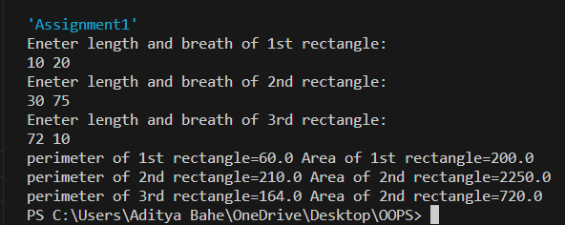

**Problem statement no.5:**

Write a program to create a class Triples, with a method which takes  
input as an integer variable and triples the data. Similarly there is another  
method which takes input as employee object and triples the salary of  
employee. Consider class employee is already created with data members  
as employee_name and salary.

**Java code:**

//Question 4

import java.util.Scanner;

class Triples{

     double n1;

    Scanner scan=new Scanner(System.in);

     double triple(){

        n1=scan.nextDouble();

        return 3*n1;

     }

     double tripleSalary(Employee emp){

       emp.Employee_name =scan.nextLine();

        emp.Salary=scan.nextDouble();

        return 3*emp.Salary;

     }

}

class Employee{

    String Employee_name;

    double Salary;

}

class Assignment1{

   public static void main(String[] args) {

    Triples tri=new Triples();

    Employee emp=new Employee();

    System.out.println("Enter employee name and salary:");

    System.out.println("Result="+tri.tripleSalary(emp));

    System.out.println("Enter a integer:");

    System.out.println("Result="+tri.triple());

   }

}

**Screen shot of output:**

